Project Title: NW Realite Property Performance Analysis-Data Analyst Practical Assessment
Name: Beyonce Ngina
Date: February 2026
Tools Used: MySQL, Microsoft Excel (Data Modeling & Dashboards)

2. Technical Methodology
Short notes listing issues found & cleaning decisions:
- rent_per_month contained negative values – used absolute value transformation to standardize all rent to positive as rent cannot be negative.
- Identified missing email for Tenant ID 14 – Recommended a follow up with the property manager to update contact records.
- Found several Null values – These were interpreted as "ongoing" leases for the purpose of duration & status calculations.
- Found Lease ID 7 where end_date was earlier than the start_date – These were flagged as valid_lease = 0 to exclude them from financial totals.
- Noted negative arrears – These were treated as tenant credits / prepayments.
- Standardized all location names to Proper Case for uniform reporting.
- Calculated lease duration in months using the current date as the reference date for ongoing leases.
- Created a categorical column lease_status to distinguish between ongoing, expired & invalid leases.
- Derived a new column annual_rent to facilitate yearly revenue projections.

3. Dashboard
The following dashboard provides a visual summary of the NW Realite property portfolio.
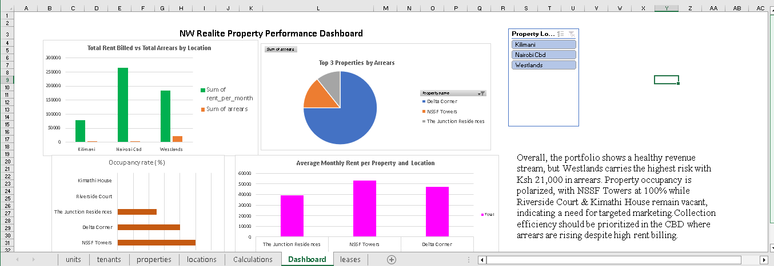

4. Memo
Dear Head of Property Management,
Following a comprehensive audit of our current SQL database, I have finalized the performance dashboard for our portfolio.
Overall Performance; The portfolio currently generates a total monthly billed rent of Ksh 526,000. However, occupancy is polarized; while NSSF Towers maintains 100% occupancy, Riverside Court and Kimathi House are currently vacant. This suggests a critical need for a pricing review or aggressive marketing in those specific zones.
Arrears & Inefficiencies Our primary financial risk is concentrated in Westlands, specifically at Delta Corner, which accounts for the vast majority of our total arrears (Ksh 21,000). Additionally, the data cleanup revealed several "Invalid Leases" where rent values were recorded as negative, indicating a need for better data entry controls.
Recommended Actions
- Arrears Follow-up: Implement a 7-day automated follow-up cadence specifically for Delta Corner tenants.
- Lease Audit: Perform a one-time audit of all digital lease entries to correct sign errors in the rent column.
- Incentives: Introduce "Early Bird" payment discounts for the Nairobi CBD properties to maintain the high collection rates seen there.
I have attached the full dashboard for your review.
Best regards,
Beyonce Ngina
Data Analyst Intern

